Batch: D - 1 Roll No.: 16010122096

Experiment / assignment / tutorial No. 07

Title: Designing test plan document for Mini Project
______________________________________________________________________
Aim: To learn and understand the way of developing the software by classical methods of software engineering. Planning and monitoring, testing, validating of the project using tools and prepares a document for the same by using the concept of software engineering
______________________________________________________________________

CO:
______________________________________________________________________

Books/ Journals/ Websites referred:
1. Roger Pressman, Software Engineering: A practitioners Approach, McGraq Hill, 2010 ,6th edition
2. Ian Somerville , Software Engineering , Addison Wesley,2011,9th edition
- http://en.wikipedia.org/wiki/Software_requirements_specification

__________________________________________________________________
Test Plan Template:
Rizz Vehicles – Online Vehicle Rental Booking Platform
Prepared by:
Romil Lodaya – 16010122096
Namit Kale – 16010122080
Dania Shah - 160101
Date – 31/10/2024

TABLE OF CONTENTS
1.0 INTRODUCTION
2.0 OBJECTIVES AND TASKS
2.1 Objectives
2.2 Tasks
3.0 SCOPE
4.0 Testing Strategy
4.1 Alpha Testing (Unit Testing)
4.2 System and Integration Testing
4.3 Performance and Stress Testing
4.4 User Acceptance Testing
4.5 Batch Testing
4.6 Automated Regression Testing
4.7 Beta Testing
5.0 Hardware Requirements
6.0 Environment Requirements
6.1 Main Frame
6.2 Workstation
7.0 Test Schedule
8.0 Control Procedures
9.0 Features to Be Tested
10.0 Features Not to Be Tested
11.0 Resources/Roles & Responsibilities
12.0 Schedules
13.0 Significantly Impacted Departments (SIDs)
14.0 Dependencies
15.0 Risks/Assumptions
16.0 Tools
17.0 Approvals
1.0 INTRODUCTION
A brief summary of the product being tested. Outline all the functions at a high level.
2.0 OBJECTIVES AND TASKS
2.1 Objectives
Describe the objectives supported by the Master Test Plan, eg., defining tasks and responsibilities, vehicle for communication, document to be used as a service level agreement, etc.
2.2 Tasks
List all tasks identified by this Test Plan, i.e., testing, post-testing, problem reporting, etc.
3.0 SCOPE
General
This section describes what is being tested, such as all the functions of a specific product, its existing interfaces, integration of all functions.
Tactics
List here how you will accomplish the items that you have listed in the “Scope” section. For example, if you have mentioned that you will be testing the existing interfaces, what would be the procedures you would follow to notify the key people to represent their respective areas, as well as allotting time in their schedule for assisting you in accomplishing your activity?
4.0 TESTING STRATEGY
Describe the overall approach to testing. For each major group of features or feature combinations, specify the approach which will ensure that these feature groups are adequately tested. Specify the major activities, techniques, and tools which are used to test the designated groups of features.
The approach should be described in sufficient detail to permit identification of the major testing tasks and estimation of the time required to do each one.
4.1 Unit Testing
Definition:
Specify the minimum degree of comprehensiveness desired. Identify the techniques which will be used to judge the comprehensiveness of the testing effort (for example, determining which statements have been executed at least once). Specify any additional completion criteria (for example, error frequency). The techniques to be used to trace requirements should be specified.
Participants:
List the names of individuals/departments who would be responsible for Unit Testing.
Methodology:
Describe how unit testing will be conducted. Who will write the test scripts for the unit testing, what would be the sequence of events of Unit Testing and how will the testing activity take place?
4.2 System and Integration Testing
Definition:
List what is your understanding of System and Integration Testing for your project.
Participants:
Who will be conducting System and Integration Testing on your project? List the individuals that will be responsible for this activity.
Methodology:
Describe how System & Integration testing will be conducted. Who will write the test scripts for the unit testing, what would be sequence of events of System & Integration Testing, and how will the testing activity take place?
4.3 Performance and Stress Testing
Definition:
List what is your understanding of Stress Testing for your project.
Participants:
Who will be conducting Stress Testing on your project? List the individuals that will be responsible for this activity.
Methodology:
Describe how Performance & Stress testing will be conducted. Who will write the test scripts for the testing, what would be sequence of events of Performance & Stress Testing, and how will the testing activity take place?
4.4 User Acceptance Testing
Definition:
The purpose of acceptance test is to confirm that the system is ready for operational use. During acceptance test, end-users (customers) of the system compare the system to its initial requirements.
Participants:
Who will be responsible for User Acceptance Testing? List the individuals’ names and responsibility.
Methodology:
Describe how the User Acceptance testing will be conducted. Who will write the test scripts for the testing, what would be sequence of events of User Acceptance Testing, and how will the testing activity take place?
4.5 Batch Testing
4.6 Automated Regression Testing
Definition:
Regression testing is the selective retesting of a system or component to verify that modifications have not caused unintended effects and that the system or component still works as specified in the requirements.
Participants:
Methodology:
4.7 Beta Testing
Participants:
Methodology:
5.0 HARDWARE REQUIREMENTS
Computers
Modems
6.0 ENVIRONMENT REQUIREMENTS
------------
6.1 Main Frame
Specify both the necessary and desired properties of the test environment. The specification should contain the physical characteristics of the facilities, including the hardware, the communications and system software, the mode of usage (for example, stand-alone), and any other software or supplies needed to support the test. Also specify the level of security which must be provided for the test facility, system software, and proprietary components such as software, data, and hardware.
Identify special test tools needed. Identify any other testing needs (for example, publications or office space). Identify the source of all needs which are not currently available to your group.
6.2 Workstation
7.0 TEST SCHEDULE
Include test milestones identified in the Software Project Schedule as well as all item transmittal events.
Define any additional test milestones needed. Estimate the time required to do each testing task. Specify the schedule for each testing task and test milestone. For each testing resource (that is, facilities, tools, and staff), specify its periods of use.
8.0 CONTROL PROCEDURES
Problem Reporting
Document the procedures to follow when an incident is encountered during the testing process. If a standard form is going to be used, attach a blank copy as an “Appendix” to the Test Plan. In the event you are using an automated incident logging system, write those procedures in this section.
Change Requests
Document the process of modifications to the software. Identify who will sign off on the changes and what would be the criteria for including the changes to the current product. If the changes will affect existing programs, these modules need to be identified.
9.0 FEATURES TO BE TESTED
Identify all software features and combinations of software features that will be tested.
10.0 FEATURES NOT TO BE TESTED
Identify all features and significant combinations of features which will not be tested and the reasons.
11.0 RESOURCES/ROLES & RESPONSIBILITIES
Specify the staff members who are involved in the test project and what their roles are going to be (for example, Mary Brown (User) compile Test Cases for Acceptance Testing). Identify groups responsible for managing, designing, preparing, executing, and resolving the test activities as well as related issues. Also identify groups responsible for providing the test environment. These groups may include developers, testers, operations staff, testing services, etc.
12.0 SCHEDULES
Major Deliverables
Identify the deliverable documents. You can list the following documents:
– Test Plan
– Test Cases
– Test Incident Reports
– Test Summary Reports
13.0 SIGNIFICANTLY IMPACTED DEPARTMENTS (SIDs)
Department/Business Area Bus. Manager Tester(s)
14.0 DEPENDENCIES
Identify significant constraints on testing, such as test-item availability, testing-resource availability, and deadlines.
15.0 RISKS/ASSUMPTIONS
Identify the high-risk assumptions of the test plan. Specify contingency plans for each (for example, delay in delivery of test items might require increased night shift scheduling to meet the delivery date).
16.0 TOOLS
List the Automation tools you are going to use. List also the Bug tracking tool here.
17.0 APPROVALS
Specify the names and titles of all persons who must approve this plan. Provide space for the signatures and dates.
Name (In Capital Letters) Signature Dat

C++ Code:
#include <iostream>
#include <string>
using namespace std;

int main() {
string username, password;
string storedUsername = "user";
string storedPassword = "pass";

cout << "Enter Username: ";
cin >> username;
cout << "Enter Password: ";
cin >> password;

if (username == storedUsername) {
if (password == storedPassword) {
cout << "Login Successful\n";
} else {
cout << "Incorrect Password\n";
}
} else {
cout << "Username Not Found\n";
}

return 0;
}

Flow Chart & Cyclomatic C0mplexity:

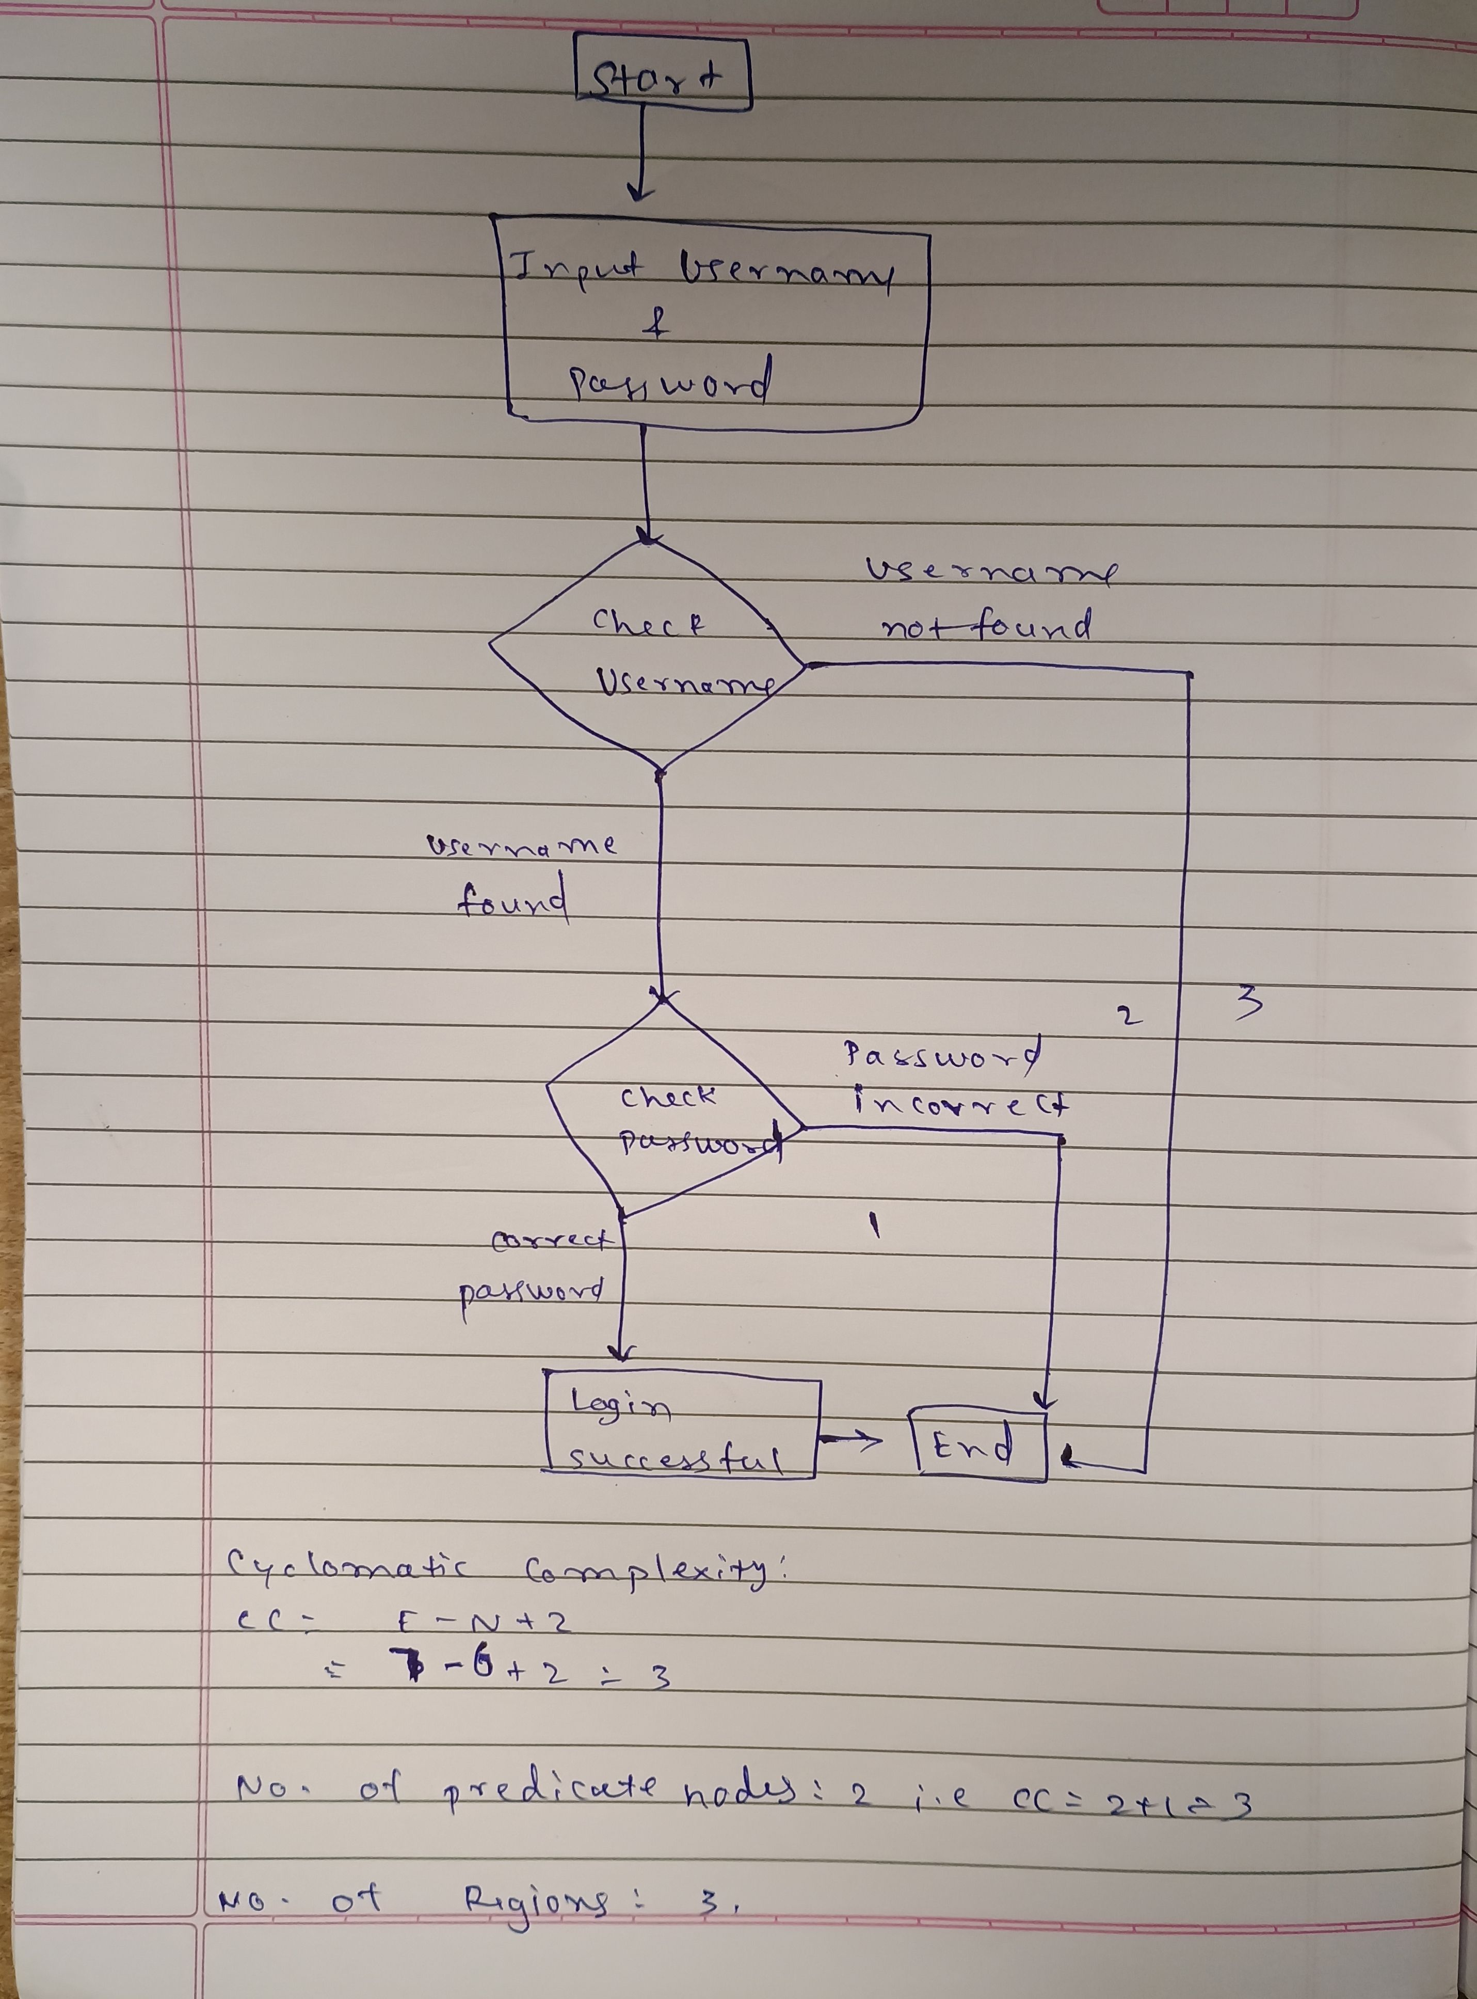

Equivalence Class Partition:

The seasonal discounts, we have:
- Class 1: No discount (off - season)
- Class 2: 5% discount during non-peak periods (off - season)
- Class 3: 10% discount during winter vacation
- Class 4: 15% discount during summer vacation
- Class 5: Invalid input (e.g., non-numeric or negative rental duration)

Test Case ID | Rental Duration (Days) | Season | Discount | Description
TC1 | -5 | Any Season | Error | Invalid input (negative rental duration input)
TC2 | 1 | Off - Season | 0%
  Off-season, no discount
TC3 | 7 | Summer Vacation | 10% | Lower boundary for summer vacation
TC4 | 14 | Summer Vacation | 15% | Mid-range duration, summer vacation
TC5 | 28 | Summer Vacation | 20% | Upper boundary for summer vacation
TC6 | 5 | Winter Vacation | 5% | Lower boundary for winter vacation
TC7 | 15 | Winter Vacation | 10% | Mid-range duration, winter vacation
TC8 | 20 | Winter Vacation | 15% | Upper range for winter vacation
TC9 | “five” | Any Season | Error | Invalid input (non-numeric duration input)
TC10 | 7 | Off - Season | 5% | Off – Season discount

Valid Input Classes:
- Class 1: Off-Season (No discount) – TC2
- Class 2: Off-Season (5% discount) – TC10
- Class 3: Winter Vacation (10% discount) – TC7
- Class 4: Summer Vacation (15% discount) – TC4
- Class 5: Invalid Input (e.g., negative or non-numeric) – TC1, TC9

Discount Scenarios and Test Case Coverage
- Off-Season
  - No Discount: Applicable in TC2.
  - 5% Discount: Applied in TC10.
- Summer Vacation
  - 10% Discount: Applied to lower boundary in TC3.
  - 15% Discount: Mid-range duration for summer vacation in TC4.
  - 20% Discount: Upper boundary for summer vacation in TC5.
- Winter Vacation
  - 5% Discount: Lower boundary of winter vacation discount in TC6.
  - 10% Discount: Mid-range duration for winter vacation in TC7.
  - 15% Discount: Upper range for winter vacation in TC8.
- Invalid Input Cases
  - Negative Rental Duration: TC1.
  - Non-Numeric Duration: TC9.

Boundary Value Analysis

Boundary Value Analysis (BVA) focused on the login page, covering typical fields such as username (or email) and password:

Username/Email Field
- Minimum Length:
  - Test with "" (empty input) – invalid.
  - Test with "a" (1 character) – invalid length.
- Valid Length:
  - Test with "user@example.com" (valid email format) – valid.
- Maximum Length:
  - Test with a 16-character username or email – valid.
  - Test with a 17-character username or email – invalid if limit is 16.

Password Field
- Minimum Length:
  - Test with "" (empty input) – invalid.
  - Test with "a1B!2d" (fewer than 8 characters) – invalid.
- Valid Length:
  - Test with "a1B!2d#E" (exactly 8 characters) – valid.
- Maximum Length:
  - Test with a 16-character password – valid.
  - Test with a 17-character password – invalid if limit is 16.

These boundary cases ensure that the login page effectively handles inputs at both the minimum and maximum boundaries for username and password fields, covering both valid and invalid scenarios.

Post Lab Descriptive Questions:

- Distinguish between Black Box and White Box Testing

• Black Box Testing: This type of testing focuses on testing the application’s functionality without looking at its internal code structure or implementation details. Testers verify the input-output relationship and validate whether the software behaves as expected based on requirements. Techniques used in black box testing include equivalence partitioning, boundary value analysis, and decision table testing.
• White Box Testing: Also known as clear box or glass box testing, this approach involves testing the internal structures or workings of an application. The tester needs knowledge of the code and implementation details to design test cases that cover statements, branches, paths, and conditions. White box testing helps identify hidden errors within the code and is commonly performed by developers.

- Consider following scenario: An institute is interested in developing a Library Information System (LIS) for the benefit of students and employees of the institute. LIS will enable the members to borrow a book (or return it) with ease while sitting at his desk/chamber. The system also enables a member to extend the date of his borrowing if no other booking for that particular book has been made. For the library staff, this system aids them to easily handle day-to-day book transactions. The librarian, who has administrative privileges and complete control over the system, can enter a new record into the system when a new book has been purchased, or remove a record in case any book is taken off the shelf. Any non-member is free to use this system to browse/search books online. However, issuing or returning books is restricted to valid users (members) of LIS only.

The final deliverable would a web application (using the recent HTML 5), which should run only within the institute LAN. Although this reduces security risk of the software to a large extent, care should be taken no confidential information (e.g. passwords) is stored in plain text.

Given the requirements of the Library Information System, the LIS web application will provide the following features:
- Functional Features:
  - Borrowing and Returning Books: Members can borrow or return books directly from their desks.
  - Extension of Borrowing Period: Members may extend their borrowing period if the book is not already reserved by another member.
  - Book Search and Browsing: Available to all users, including non-members, to look up books in the library’s collection.
  - Book Inventory Management: Library staff and administrators can add or remove books as needed.
  - Admin Privileges: The librarian has full access to add or remove records, manage inventory, and update the system.
- Security and Access Restrictions:
  - Member-Only Access: Book issuing and returning are restricted to LIS members only.
  - Network Limitation: The application is accessible only within the institute’s LAN, minimizing external security risks.
  - Confidential Data Storage: Sensitive information, such as passwords, will not be stored in plain text.
- Technological Requirements:
  - Web Application: Built using HTML5 to be compatible with modern browsers.
  - LAN-Based Deployment: Runs within the institute’s network, leveraging LAN restrictions for security.

This system will simplify and streamline book borrowing and returning processes for students and staff, as well as inventory management for librarians, while maintaining a focus on security and limited access.
Assume following test suite is used

A test suite to verify the "User Login" feature
# |  | TS1
Title |  | Verify "User Login" functionality
Description |  | To test the different scenarios that might arise while an user is trying to login
# | Summary | Dependency | Pre-condition | Post-condition | Execution Steps | Expected Output
TC1 | Verify that user already registered with the LIS is able to login with correct user ID and password |  | Employee ID 149405 is a registered user of LIS; user's password is this_is_password | User is logged in | - Type in employee ID as 149405  - Type in password this_is_password  - Click on the 'Login' button | "Home" page for the user is displayed
TC2 | Verify that an unregistered user of LIS is unable to login |  | Employee ID 149405xx is not a registered user of LIS | User is not logged in | - Type in employee ID as 149405xx  - Type in password whatever  - Click on the 'Login' button | The "Login" dialog is shown with a "Login failed! Check your user ID and password" message
TC3 | Verify that user already registered with the LIS is unable to login with incorrect password |  | Employee ID 149405 is a registered user of LIS; user's password is this_is_password | User is not logged in | - Type in employee ID as 149405  - Type in password whatever  - Click on the 'Login' button | The "Login" dialog is shown with a "Login failed! Check your user ID and password" message
TC4 | Verify that user already registered with the LIS is unable to login with incorrect password given twice consecutively | TC3 | This test case is executed after execution of TC3 before executing any other test case | User is not logged in | - Type in employee ID as 149405  - Type in password whatever2  - Click on the 'Login' button | The "Login" dialog is shown with a "Login failed! Check your user ID and password" message
TC5 | Verify that user already registered with the LIS is unable to login with incorrect password given thrice consecutively | TC4 | This test case is executed after execution of TC4 before executing any other test case | User is not logged in | - Type in employee ID as 149405  - Type in password whatever3  - Click on the 'Login' button | The "Login" dialog is shown with a "Login failed! Check your user ID and password" message; the security question and input box for the answer are displayed
TC6 | Verify that a registered user can login after three consecutive failures by correctly answering the security question | TC5 | This test case is executed after execution of TC6 before executing any other test case. Answer to the security question is my_answer. | Email sent containing new password. The email is expected to be received within 2 minute. | - Type in the answer as my_answer  - Click on the 'Email Password' button | Login dialog is displayed; an email containing the new password is received
TC7 | Verify that a registered user's account is blocked after three consecutive failures and answering the security question incorrectly |  | Execute the test cases TC3, TC4, and TC5 once again (in order) before executing this test case | User account has been blocked | - Type in the answer as not_my_answer  - Click on the 'Email Password' button | The message "Your account has been blocked! Please contact the administrator." appears

create a Requirements Traceability Matrix (RTM) showing a mapping from individual requirement to test case(s).

Table 1: A simplified mapping from requirements to test cases
Requirement # | Test Case #
R1
R2
R3
R4

Consider requirements are summarized in the table below

# | Requirement
R1 | New user registration
R2 | User Login
R3 | Search book
R4 | Issue book
R5 | Return book
R6 | Reissue book

